Python Programming
Lab Exercise
Q1: Import the given dataset “UScereal” and perform the following using PANDAS. For each output, give the interpretation with respect to the imported dataset. About Dataset: The UScereal data set has been collected from the 1993-ASA Statistical Graphics Exposition, and is taken from the mandatory F&DA food label. The recorded variables are:

● mfr-Manufacturer, represented by its first initial: G=General Mills,
K=Kelloggs, N=Nabisco, P=Post, Q=Quaker Oats, R=Ralston Purina.
● calories - number of calories in one portion.
● protein - grams of protein in one portion.
● fat - grams of fat in one portion.
● sodium - milligrams of sodium in one portion.
● fibre - grams of dietary fibre in one portion.
● carbo -grams of complex carbohydrates in one portion.
● sugars -grams of sugars in one portion.
● shelf-display shelf (1, 2, or 3, counting from the floor).
● potassium - grams of potassium.
● vitamins-vitamins and minerals (none, enriched, or 100%).

a. Import the given "UScereal" dataset.
Code:
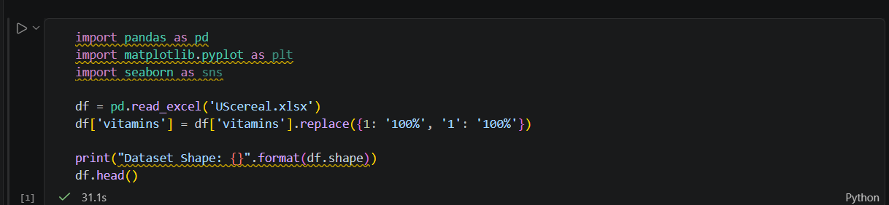

Output:
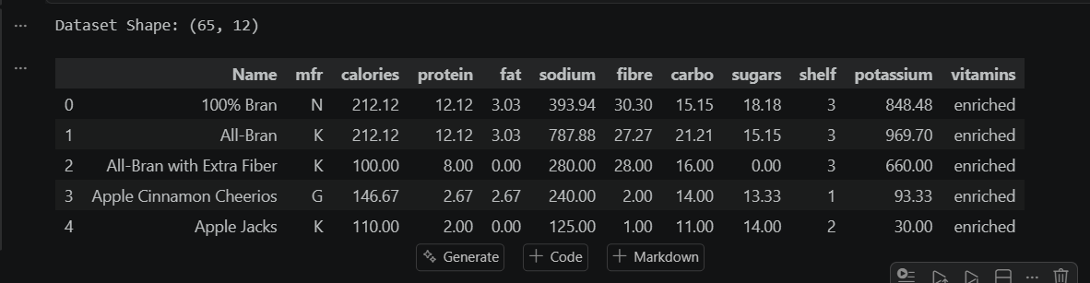
b. Find summary statistics of a dataset.
Code:

Output:
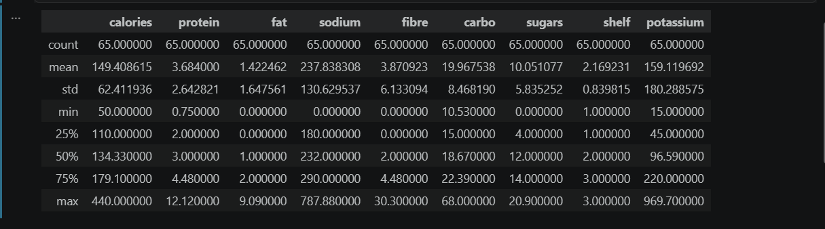
c. Are there any missing values?
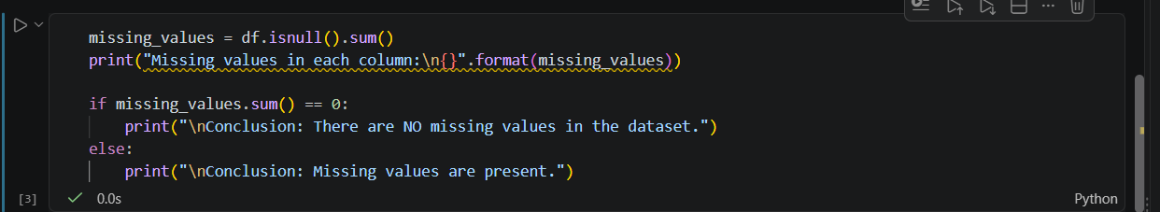
Code:

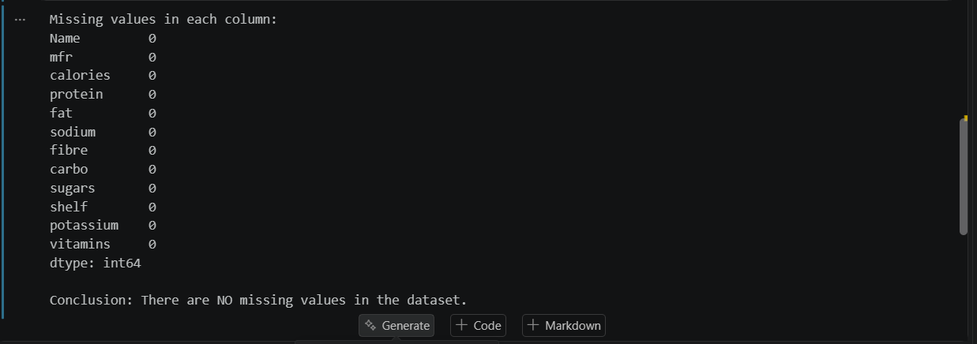
Output:

d. Find average protein value of each Manufacturer.
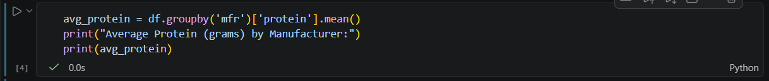
Code:

Output:
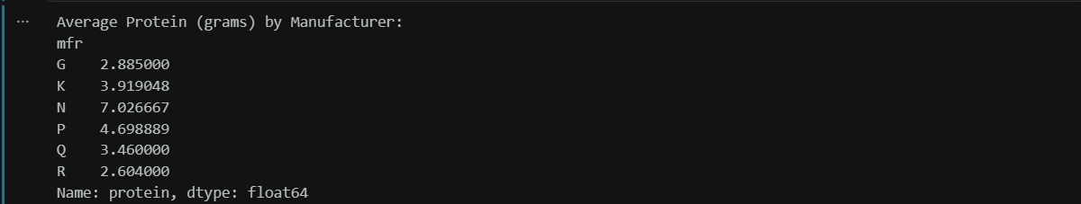
e. Find the name of the Cereal with high sugar from Manufacturer G.
Code:
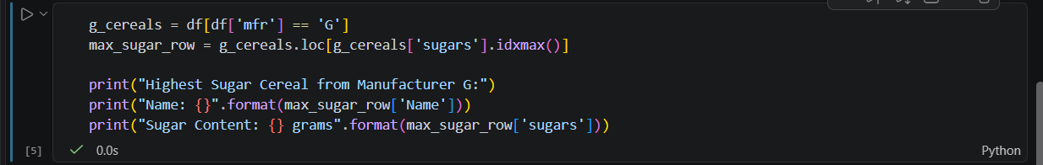
Output:

f. Generate any three different suitable plots for the following. Use appropriate
formatting like title, legend, x-value, y-value ect.
a.Using only shelf or vitamins
Code:
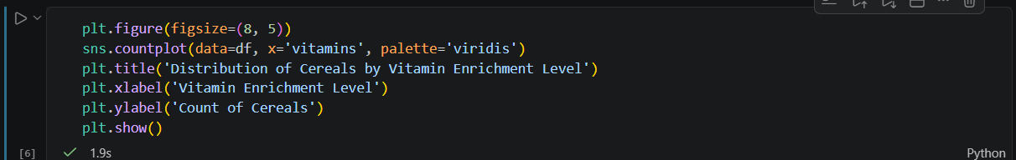
Output:
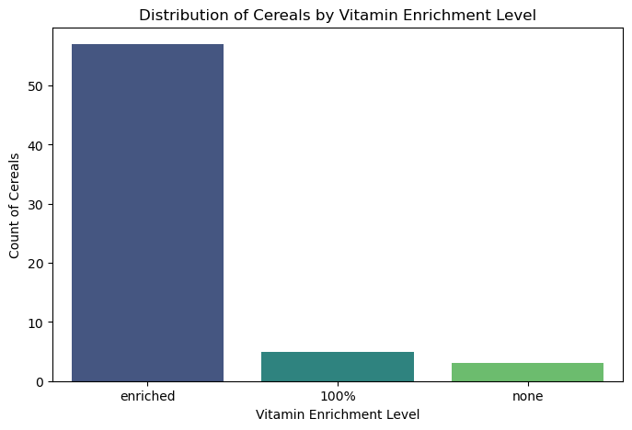

b. Using mfr and fiber
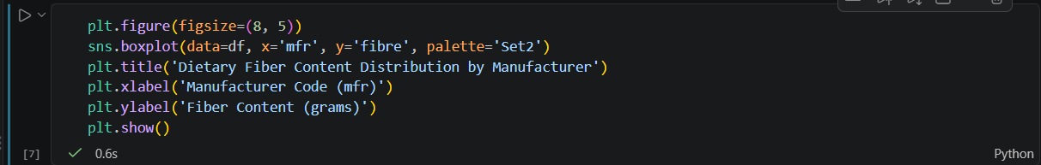
Code:

Output:
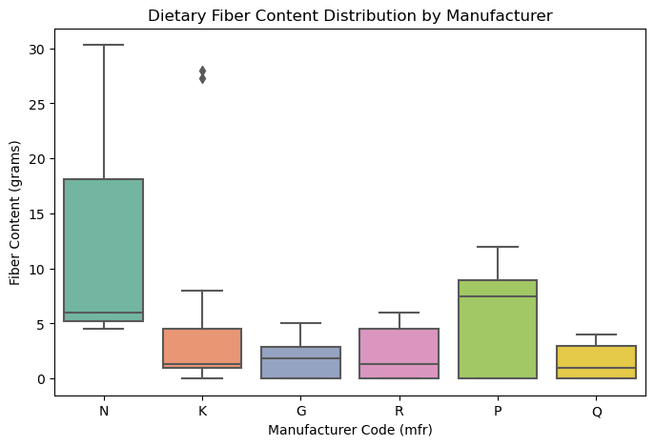

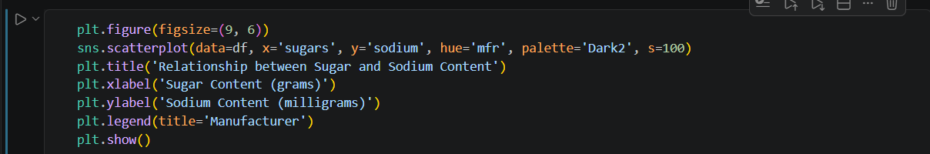
c. Using sodium and sugars
Code:

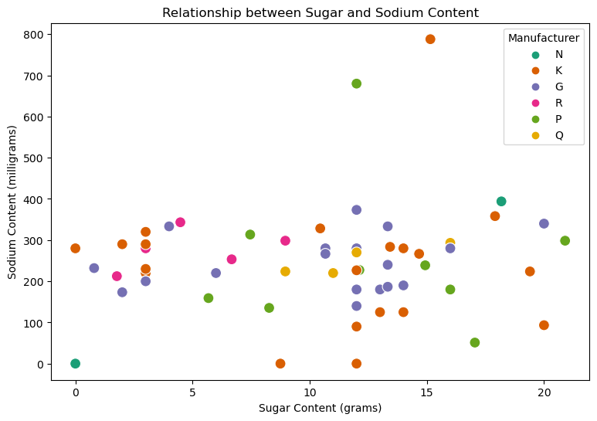
Output:

